Module Name: Login Page
Test Case ID: 1
Webpage URL: https://practicetestautomation.com/practice-test-login/

Scenario ID: 1
Scenario: Sign up with valid id and password
Test Steps:
1 - Open login page
2 - enter Username
3 - Enter a password
4 - Click on login button
Screenshots:
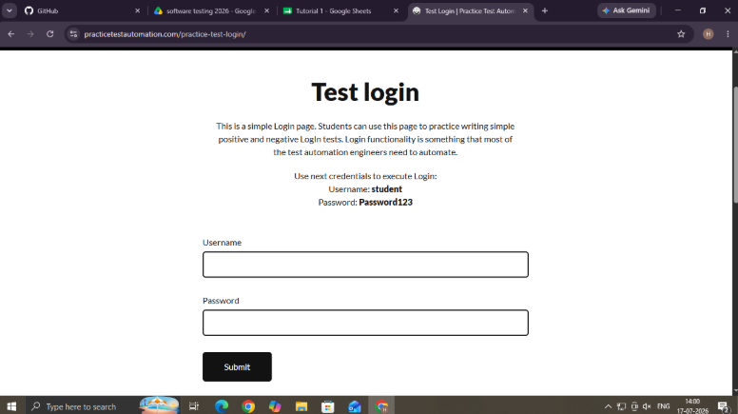

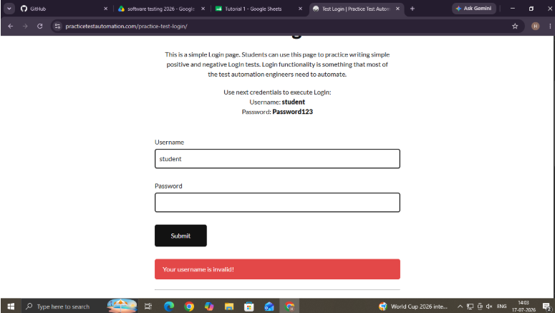

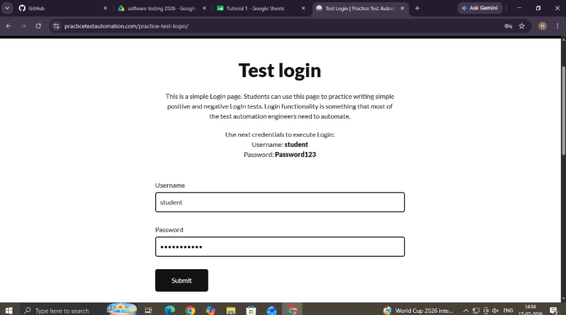

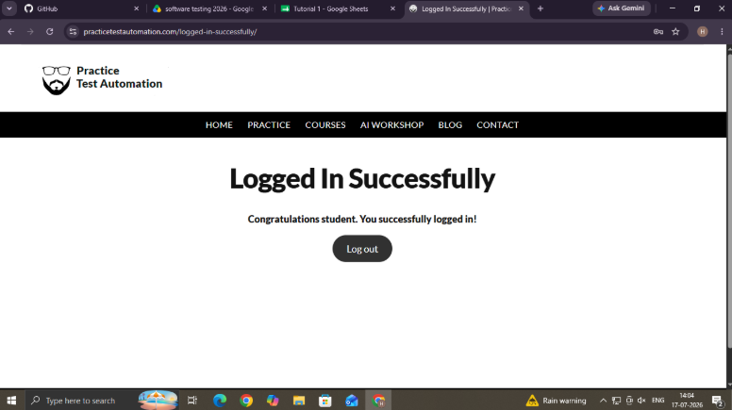

Module Name: Login Page
Test Case ID: 2
Webpage URL: https://practicetestautomation.com/practice-test-login/

Scenario ID: 2
Scenario: Sign up with invalid id and password
Test Steps:
1 - Open login page
2 - enter Username
3 - Enter a password
4 - Click on login button
Screenshots:

